EXPERIMENT NO 6

MainActivity.java :

package com.example.cal;

import androidx.appcompat.app.AppCompatActivity;

import android.os.Bundle;
import android.view.View;
import android.widget.Button;
import android.widget.EditText;

public class MainActivity extends AppCompatActivity {

@Override
protected void onCreate(Bundle savedInstanceState) {
super.onCreate(savedInstanceState);
setContentView(R.layout.activity_main);

Button add = (Button) findViewById(R.id.add);
Button sub=(Button) findViewById(R.id.sub);
Button mul = (Button) findViewById(R.id.mul);
Button div = (Button) findViewById(R.id.div);

final EditText no1 = (EditText) findViewById(R.id.No1);
final EditText no2 = (EditText) findViewById(R.id.No2);
final EditText r = (EditText) findViewById(R.id.result);

add.setOnClickListener(new View.OnClickListener() {

public void onClick(View v)
{
Double a=Double.parseDouble(no1.getText().toString());
Double b=Double.parseDouble(no2.getText().toString());
Double sum=a+b;
r.setText(Double.toString(sum));
}
});
add.setOnClickListener(new View.OnClickListener() {

public void onClick(View v)
{
Double a=Double.parseDouble(no1.getText().toString());
Double b=Double.parseDouble(no2.getText().toString());
Double sum=a+b;
r.setText(Double.toString(sum));
}
});
sub.setOnClickListener(new View.OnClickListener() {

public void onClick(View v)
{
Double a=Double.parseDouble(no1.getText().toString());
Double b=Double.parseDouble(no2.getText().toString());
Double sum=a-b;
r.setText(Double.toString(sum));
}
});
mul.setOnClickListener(new View.OnClickListener() {

public void onClick(View v)
{
Double a=Double.parseDouble(no1.getText().toString());
Double b=Double.parseDouble(no2.getText().toString());
Double sum=a*b;
r.setText(Double.toString(sum));
}
});
div.setOnClickListener(new View.OnClickListener() {

public void onClick(View v)
{
Double a=Double.parseDouble(no1.getText().toString());
Double b=Double.parseDouble(no2.getText().toString());
Double sum=a/b;
r.setText(Double.toString(sum));
}
});

}
}

activity_main.xml:

<?xml version="1.0" encoding="utf-8"?>
<androidx.constraintlayout.widget.ConstraintLayout xmlns:android="http://schemas.android.com/apk/res/android"
xmlns:app="http://schemas.android.com/apk/res-auto"
xmlns:tools="http://schemas.android.com/tools"
android:layout_width="match_parent"
android:layout_height="match_parent"
tools:context=".MainActivity">

<Button
android:id="@+id/add"
android:layout_width="wrap_content"
android:layout_height="wrap_content"
android:layout_marginTop="376dp"
android:text="Addition"
app:layout_constraintEnd_toEndOf="parent"
app:layout_constraintHorizontal_bias="0.835"
app:layout_constraintStart_toStartOf="parent"
app:layout_constraintTop_toTopOf="parent" />

<Button
android:id="@+id/sub"
android:layout_width="wrap_content"
android:layout_height="wrap_content"
android:layout_marginTop="376dp"
android:text="substaction"
app:layout_constraintEnd_toEndOf="parent"
app:layout_constraintHorizontal_bias="0.217"
app:layout_constraintStart_toStartOf="parent"
app:layout_constraintTop_toTopOf="parent" />

<Button
android:id="@+id/mul"
android:layout_width="wrap_content"
android:layout_height="wrap_content"
android:layout_marginTop="308dp"
android:text="Multiplication"
app:layout_constraintEnd_toEndOf="parent"
app:layout_constraintHorizontal_bias="0.163"
app:layout_constraintStart_toStartOf="parent"
app:layout_constraintTop_toTopOf="parent" />

<Button
android:id="@+id/div"
android:layout_width="wrap_content"
android:layout_height="wrap_content"
android:layout_marginTop="308dp"
android:text="division"
app:layout_constraintEnd_toEndOf="parent"
app:layout_constraintHorizontal_bias="0.835"
app:layout_constraintStart_toStartOf="parent"
app:layout_constraintTop_toTopOf="parent" />

<EditText
android:id="@+id/No2"
android:layout_width="wrap_content"
android:layout_height="wrap_content"
android:layout_marginTop="192dp"
android:ems="10"
android:inputType="textPersonName"
android:text=""
app:layout_constraintEnd_toEndOf="parent"
app:layout_constraintHorizontal_bias="0.348"
app:layout_constraintStart_toStartOf="parent"
app:layout_constraintTop_toTopOf="parent" />

<EditText
android:id="@+id/No1"
android:layout_width="wrap_content"
android:layout_height="wrap_content"
android:layout_marginTop="124dp"
android:ems="10"
android:inputType="textPersonName"
android:text=""
app:layout_constraintEnd_toEndOf="parent"
app:layout_constraintHorizontal_bias="0.348"
app:layout_constraintStart_toStartOf="parent"
app:layout_constraintTop_toTopOf="parent" />

<EditText
android:id="@+id/result"
android:layout_width="wrap_content"
android:layout_height="wrap_content"
android:layout_marginTop="260dp"
android:ems="10"
android:inputType="textPersonName"
android:text="Result"
app:layout_constraintEnd_toEndOf="parent"
app:layout_constraintHorizontal_bias="0.393"
app:layout_constraintStart_toStartOf="parent"
app:layout_constraintTop_toTopOf="parent" />

</androidx.constraintlayout.widget.ConstraintLayout>

Output:

addition subtraction
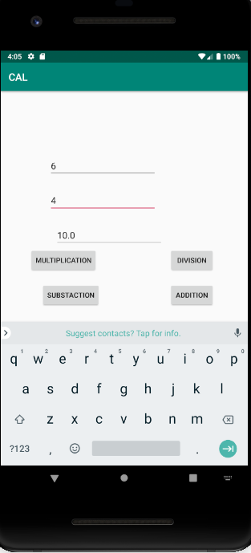
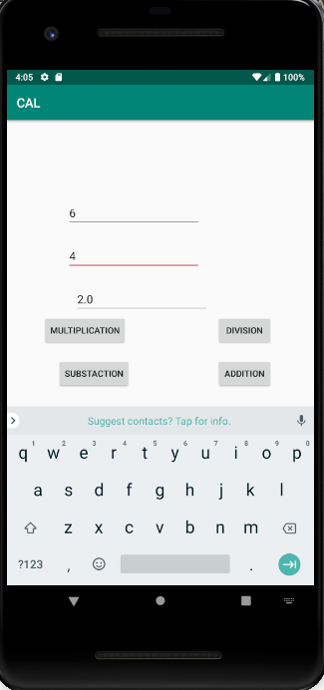

multiplication division

